BÁO CÁO BÀI TẬP VỀ NHÀ
Họ và tên: Nguyễn Quốc Khánh
Mssv: 20225866

Bài tập:
+ Sử dụng Fragment và NavigationController để tạo các trang với các chức năng: Hiển thị danh sách sinh viên, Thêm sinh viên mới, Cập nhật thông tin sinh viên.
+ Sử dụng ViewModel để lưu trữ và chia sẻ dữ liệu giữa các Fragment.
+ Sử dụng Data Binding cho giao diện Thêm sinh viên và Cập nhật thông tin sinh viên.

Link github:
Mã nguồn:
Layout_add_student_fragment:
<?xml version="1.0" encoding="utf-8"?>
<androidx.constraintlayout.widget.ConstraintLayout xmlns:android="http://schemas.android.com/apk/res/android"
xmlns:app="http://schemas.android.com/apk/res-auto"
xmlns:tools="http://schemas.android.com/tools"
android:layout_width="match_parent"
android:layout_height="match_parent"
android:layout_margin="0dp"
android:background="@drawable/bg_white_corner_16"
android:paddingBottom="0dp">
<TextView
android:id="@+id/title_add"
android:layout_width="match_parent"
android:layout_height="wrap_content"
android:gravity="center"
android:padding="16dp"
android:paddingStart="10dp"
android:text="@string/add_new"
android:textColor="#287C00"
android:textSize="20sp"
android:textStyle="bold"
app:layout_constraintEnd_toEndOf="parent"
app:layout_constraintStart_toStartOf="parent"
app:layout_constraintTop_toTopOf="parent"
tools:ignore="RtlSymmetry" />
<EditText
android:id="@+id/edit_name"
android:layout_width="0dp"
android:layout_height="wrap_content"
android:layout_margin="16dp"
android:autofillHints="@string/student_name"
android:background="@drawable/bg_white_corner_10_border_gray"
android:ems="10"
android:hint="@string/student_name"
android:inputType="text"
android:minHeight="48dp"
android:padding="12dp"
android:textColorHint="#757575"
android:textSize="15sp"
app:layout_constraintEnd_toEndOf="parent"
app:layout_constraintStart_toStartOf="parent"
app:layout_constraintTop_toBottomOf="@+id/title_add" />
<EditText
android:id="@+id/edit_id"
android:layout_width="0dp"
android:layout_height="wrap_content"
android:layout_margin="16dp"
android:autofillHints="MSSV"
android:background="@drawable/bg_white_corner_10_border_gray"
android:ems="10"
android:hint="@string/student_id"
android:inputType="text"
android:minHeight="48dp"
android:padding="12dp"
android:textColorHint="#757575"
android:textSize="15sp"
app:layout_constraintEnd_toEndOf="parent"
app:layout_constraintStart_toStartOf="parent"
app:layout_constraintTop_toBottomOf="@+id/edit_name" />
<Button
android:id="@+id/btn_cancel"
android:layout_width="0dp"
android:layout_height="wrap_content"
android:layout_margin="16dp"
android:layout_weight="1"
android:backgroundTint="#E93F3F"
android:text="@string/cancel"
android:textSize="15sp"
app:layout_constraintEnd_toStartOf="@+id/btn_add"
app:layout_constraintStart_toStartOf="parent"
app:layout_constraintTop_toBottomOf="@+id/edit_id" />
<Button
android:id="@+id/btn_add"
android:layout_width="0dp"
android:layout_height="wrap_content"
android:layout_margin="16dp"
android:layout_weight="1"
android:backgroundTint="#579D12"
android:text="@string/save"
android:textSize="15sp"
app:layout_constraintEnd_toEndOf="parent"
app:layout_constraintStart_toEndOf="@+id/btn_cancel"
app:layout_constraintTop_toBottomOf="@+id/edit_id" />
</androidx.constraintlayout.widget.ConstraintLayout>

Layout_fragment_edit:
<?xml version="1.0" encoding="utf-8"?>
<androidx.constraintlayout.widget.ConstraintLayout xmlns:android="http://schemas.android.com/apk/res/android"
xmlns:app="http://schemas.android.com/apk/res-auto"
xmlns:tools="http://schemas.android.com/tools"
android:layout_width="match_parent"
android:layout_height="match_parent"
android:layout_margin="0dp"
android:background="#FFFFFF"
android:backgroundTint="#FFFFFF"
android:paddingBottom="0dp">
<TextView
android:id="@+id/title_add"
android:layout_width="match_parent"
android:layout_height="wrap_content"
android:background="@drawable/bg_green_corner_16"
android:backgroundTint="#FFFFFF"
android:gravity="center"
android:padding="16dp"
android:paddingStart="10dp"
android:text="@string/edit_information"
android:textColor="#088C56"
android:textSize="20sp"
android:textStyle="bold"
app:layout_constraintEnd_toEndOf="parent"
app:layout_constraintStart_toStartOf="parent"
app:layout_constraintTop_toTopOf="parent"
tools:ignore="RtlSymmetry" />
<EditText
android:id="@+id/update_name"
android:layout_width="0dp"
android:layout_height="wrap_content"
android:layout_margin="16dp"
android:autofillHints="@string/student_name"
android:background="@drawable/bg_white_corner_10_border_gray"
android:ems="10"
android:hint="@string/student_name"
android:inputType="text"
android:minHeight="48dp"
android:padding="12dp"
android:textColorHint="#757575"
android:textSize="15sp"
app:layout_constraintEnd_toEndOf="parent"
app:layout_constraintStart_toStartOf="parent"
app:layout_constraintTop_toBottomOf="@+id/title_add" />
<EditText
android:id="@+id/update_id"
android:layout_width="0dp"
android:layout_height="wrap_content"
android:layout_margin="16dp"
android:autofillHints="MSSV"
android:background="@drawable/bg_white_corner_10_border_gray"
android:ems="10"
android:hint="@string/student_id"
android:inputType="text"
android:minHeight="48dp"
android:padding="12dp"
android:textColorHint="#757575"
android:textSize="15sp"
app:layout_constraintEnd_toEndOf="parent"
app:layout_constraintStart_toStartOf="parent"
app:layout_constraintTop_toBottomOf="@+id/update_name" />
<Button
android:id="@+id/btn_cancel_update"
android:layout_width="0dp"
android:layout_height="wrap_content"
android:layout_margin="16dp"
android:layout_weight="1"
android:backgroundTint="#FA3636"
android:text="@string/cancel"
android:textSize="15sp"
app:layout_constraintEnd_toStartOf="@+id/btn_update"
app:layout_constraintStart_toStartOf="parent"
app:layout_constraintTop_toBottomOf="@+id/update_id" />
<Button
android:id="@+id/btn_update"
android:layout_width="0dp"
android:layout_height="wrap_content"
android:layout_margin="16dp"
android:layout_weight="1"
android:backgroundTint="#2D970A"
android:text="@string/update"
android:textSize="15sp"
app:layout_constraintEnd_toEndOf="parent"
app:layout_constraintStart_toEndOf="@+id/btn_cancel_update"
app:layout_constraintTop_toBottomOf="@+id/update_id" />
</androidx.constraintlayout.widget.ConstraintLayout>

Layout_fragment_remote:
<?xml version="1.0" encoding="utf-8"?>
<androidx.constraintlayout.widget.ConstraintLayout xmlns:android="http://schemas.android.com/apk/res/android"
xmlns:app="http://schemas.android.com/apk/res-auto"
xmlns:tools="http://schemas.android.com/tools"
android:layout_width="match_parent"
android:layout_height="match_parent"
android:background="@drawable/bg_white_corner_16"
android:layout_margin="16dp"
android:paddingBottom="16dp">
<TextView
android:id="@+id/title_remove"
android:layout_width="match_parent"
android:layout_height="wrap_content"
android:background="@drawable/bg_red_corner_16"
android:gravity="center"
android:padding="16dp"
android:paddingStart="10dp"
android:text="@string/remove_student"
android:textColor="@color/white"
android:textSize="20sp"
android:textStyle="bold"
app:layout_constraintEnd_toEndOf="parent"
app:layout_constraintStart_toStartOf="parent"
app:layout_constraintTop_toTopOf="parent"
tools:ignore="RtlSymmetry" />
<TextView
android:id="@+id/remove_confirm"
android:layout_width="match_parent"
android:layout_height="wrap_content"
app:layout_constraintTop_toBottomOf="@+id/title_remove"
android:text="@string/remove_student_confirm"
android:gravity="center"
android:textStyle="bold"
android:textSize="18sp"
android:padding="20dp"
android:paddingStart="40dp"
android:paddingEnd="40dp"
android:maxLines="2"
android:ellipsize="none"
android:breakStrategy="simple"
android:lineSpacingExtra="2dp"
/>
<Button
android:id="@+id/btn_cancel_remove"
android:layout_width="0dp"
android:layout_height="wrap_content"
android:layout_margin="16dp"
android:layout_weight="1"
android:backgroundTint="#3FA94B"
android:text="@string/cancel"
android:textSize="15sp"
app:layout_constraintEnd_toStartOf="@+id/btn_remove"
app:layout_constraintStart_toStartOf="parent"
app:layout_constraintTop_toBottomOf="@+id/remove_confirm" />
<Button
android:id="@+id/btn_remove"
android:layout_width="0dp"
android:layout_height="wrap_content"
android:layout_margin="16dp"
android:layout_weight="1"
android:backgroundTint="#FB3636"
android:text="@string/remove"
android:textColorLink="#FFFFFF"
android:textSize="15sp"
app:layout_constraintEnd_toEndOf="parent"
app:layout_constraintStart_toEndOf="@+id/btn_cancel_remove"
app:layout_constraintTop_toBottomOf="@+id/remove_confirm" />
</androidx.constraintlayout.widget.ConstraintLayout>

Fragment:
AddStudentFragment:
package com.example.studentmanagement.controller
import android.os.Bundle
import android.view.LayoutInflater
import android.view.View
import android.view.ViewGroup
import android.widget.Button
import android.widget.EditText
import androidx.fragment.app.Fragment
import com.example.studentmanagement.R
class AddStudentFragment : Fragment(R.layout.layout_add_student_fragment) {
interface OnStudentAddedListener {
fun onStudentAdded(name: String, id: String)
}
private var listener: OnStudentAddedListener? = null
private fun setOnStudentAddedListener(listener: OnStudentAddedListener?) {
this.listener = listener
}
override fun onCreateView(
inflater: LayoutInflater, container: ViewGroup?,
savedInstanceState: Bundle?
): View? {
setOnStudentAddedListener(FragmentSingleton.getInstance().onStudentAddedListener)
return inflater.inflate(R.layout.layout_add_student_fragment, container, false)
}
override fun onViewCreated(view: View, savedInstanceState: Bundle?) {
super.onViewCreated(view, savedInstanceState)
val btnSave = view.findViewById<Button>(R.id.btn_add)
val btnCancel = view.findViewById<Button>(R.id.btn_cancel)
btnSave.setOnClickListener {
val name = view.findViewById<EditText>(R.id.edit_name).text.toString()
val id = view.findViewById<EditText>(R.id.edit_id).text.toString()
if (name.isNotEmpty() && id.isNotEmpty()) {
listener?.onStudentAdded(name, id)
parentFragmentManager.popBackStack()
} else {
// Xử lý lỗi nhập liệu
}
}
btnCancel.setOnClickListener {
parentFragmentManager.popBackStack()
}
}
}

EditStudentFragment:
package com.example.studentmanagement.controller
import android.content.Context
import android.os.Bundle
import android.view.LayoutInflater
import android.view.View
import android.view.ViewGroup
import android.widget.Button
import android.widget.EditText
import android.widget.Toast
import androidx.fragment.app.Fragment
import com.example.studentmanagement.R
import com.example.studentmanagement.model.Student
class EditStudentFragment : Fragment() {
private var listener: StudentActionListener? = null
private var position: Int = 0
private var student: Student? = null
fun setup(listener: StudentActionListener?, position: Int, student: Student?) {
this.listener = listener
this.position = position
this.student = student
}
override fun onCreateView(
inflater: LayoutInflater, container: ViewGroup?,
savedInstanceState: Bundle?
): View? {
setup(FragmentSingleton.getInstance().studentActionListener, FragmentSingleton.getInstance().position, FragmentSingleton.getInstance().student)
return inflater.inflate(R.layout.layout_fragment_edit, container, false)
}
override fun onViewCreated(view: View, savedInstanceState: Bundle?) {
val updateName = view.findViewById<EditText>(R.id.update_name)
val updateID = view.findViewById<EditText>(R.id.update_id)
val btnUpdate = view.findViewById<Button>(R.id.btn_update)
val btnCancel = view.findViewById<Button>(R.id.btn_cancel_update)
updateName.setText(student?.studentName)
updateID.setText(student?.studentId)
btnUpdate.setOnClickListener {
val updatedName = updateName.text.toString()
val updatedID = updateID.text.toString()
if (updatedName.isNotEmpty() && updatedID.isNotEmpty()) {
val updatedStudent = Student(updatedName, updatedID)
listener?.onEditStudent(position, updatedStudent)
Toast.makeText(requireContext(), "Updated successfully", Toast.LENGTH_SHORT).show()
parentFragmentManager.popBackStack()
} else {
Toast.makeText(requireContext(), "Please fill in all fields", Toast.LENGTH_SHORT).show()
}
}
btnCancel.setOnClickListener {
parentFragmentManager.popBackStack()
}
}
}
RemoveStudentFragment:
package com.example.studentmanagement.controller
import android.os.Bundle
import android.view.LayoutInflater
import android.view.View
import android.view.ViewGroup
import android.widget.Button
import androidx.fragment.app.Fragment
import com.example.studentmanagement.R
import com.example.studentmanagement.model.Student
class RemoveStudentFragment : Fragment() {
private var listener: StudentActionListener? = null
private var position: Int = -1
private lateinit var student: Student
fun setup(listener: StudentActionListener, position: Int, student: Student){
this.listener = listener
this.position = position
this.student = student
}
override fun onCreateView(
inflater: LayoutInflater, container: ViewGroup?,
savedInstanceState: Bundle?
): View? {
return inflater.inflate(R.layout.layout_fragment_remove, container, false)
}
override fun onViewCreated(view: View, savedInstanceState: Bundle?) {
val btnRemove = view.findViewById<Button>(R.id.btn_remove)
val btnCancel = view.findViewById<Button>(R.id.btn_cancel_remove)
btnRemove.setOnClickListener {
val mainActivityContext = requireActivity()
listener?.onRemoveStudent(position, student, mainActivityContext)
parentFragmentManager.popBackStack()
}
btnCancel.setOnClickListener {
parentFragmentManager.popBackStack()
}
}
}

MainActivity:
package com.example.studentmanagement
import android.os.Bundle
import android.util.Log
import android.view.Menu
import android.view.MenuItem
import androidx.appcompat.app.AppCompatActivity
import androidx.appcompat.widget.Toolbar
import androidx.core.view.GravityCompat
import androidx.drawerlayout.widget.DrawerLayout
import androidx.navigation.NavController
import androidx.navigation.findNavController
import androidx.navigation.ui.AppBarConfiguration
import androidx.navigation.ui.NavigationUI
import androidx.navigation.ui.setupWithNavController
import androidx.recyclerview.widget.LinearLayoutManager
import androidx.recyclerview.widget.RecyclerView
import com.example.studentmanagement.controller.AddStudentFragment
import com.example.studentmanagement.controller.FragmentSingleton
import com.example.studentmanagement.controller.StudentAdapter
import com.example.studentmanagement.database.StudentData
import com.example.studentmanagement.model.Student
import com.google.android.material.navigation.NavigationView
class MainActivity : AppCompatActivity(), OnStudentFragment {
private lateinit var studentAdapter: StudentAdapter
private lateinit var students: MutableList<Student>
override fun onCreate(savedInstanceState: Bundle?) {
super.onCreate(savedInstanceState)
setContentView(R.layout.activity_main)
// Setup Toolbar
val toolbar: Toolbar = findViewById(R.id.toolbar)
setSupportActionBar(toolbar)
// Setup DrawerLayout and NavigationView
val drawerLayout: DrawerLayout = findViewById(R.id.drawer_layout)
val navController: NavController = findNavController(R.id.nav_host_fragment)
val appBarConfiguration = AppBarConfiguration(navController.graph, drawerLayout)
NavigationUI.setupActionBarWithNavController(this, navController, appBarConfiguration)
val navView: NavigationView = findViewById(R.id.nav_view)
navView.setupWithNavController(navController)
students = StudentData.students
studentAdapter = StudentAdapter(students, this)
findViewById<RecyclerView>(R.id.recycler_view_students).run {
adapter = studentAdapter
layoutManager = LinearLayoutManager(this@MainActivity)
}
setupNav()
}
override fun onCreateOptionsMenu(menu: Menu): Boolean {
menuInflater.inflate(R.menu.add_menu, menu)
return true
}
override fun onOptionsItemSelected(item: MenuItem): Boolean {
return when (item.itemId) {
R.id.action_add_student -> {
showAddStudentFragment()
true
}
else -> super.onOptionsItemSelected(item)
}
}
override fun onSupportNavigateUp(): Boolean {
val navController = findNavController(R.id.nav_host_fragment)
val drawerLayout = findViewById<DrawerLayout>(R.id.drawer_layout)
return NavigationUI.navigateUp(navController, drawerLayout) || super.onSupportNavigateUp()
}
private fun setupNav(){
val drawerLayout: DrawerLayout = findViewById(R.id.drawer_layout)
val navView: NavigationView = findViewById(R.id.nav_view)
navView.setNavigationItemSelectedListener { menuItem ->
when (menuItem.itemId) {
R.id.list_student_nav -> {
// Navigate to the List Student Fragment
findNavController(R.id.nav_host_fragment).navigate(R.id.listStudentFragment)
drawerLayout.closeDrawer(GravityCompat.START)
true
}
R.id.add_student_nav -> {
// Navigate to the Add Student Fragment
showAddStudentFragment()
drawerLayout.closeDrawer(GravityCompat.START)
true
}
R.id.edit_student_nav -> {
// Navigate to the Edit Student Fragment
FragmentSingleton.getInstance().student?.let {
showEditStudentFragment(FragmentSingleton.getInstance().position,
it
)
drawerLayout.closeDrawer(GravityCompat.START)
}
true
}
else -> false
}
}
}
override fun showAddStudentFragment() {
FragmentSingleton.getInstance().onStudentAddedListener = object : AddStudentFragment.OnStudentAddedListener {
override fun onStudentAdded(name: String, id: String) {
Log.i("add", "add")
students.add(Student(name, id))
studentAdapter.notifyItemInserted(students.size - 1)
}
}
findNavController(R.id.nav_host_fragment).navigate(R.id.addStudentFragment)
}
override fun showRemoveStudentFragment(position: Int, student: Student) {
//findNavController(R.id.nav_host_fragment).navigate(R.id.removeStudentFragment)
}
override fun showEditStudentFragment(position: Int, student: Student) {
FragmentSingleton.getInstance().studentActionListener = studentAdapter
FragmentSingleton.getInstance().student = student
FragmentSingleton.getInstance().position = position
findNavController(R.id.nav_host_fragment).navigate(R.id.editStudentFragment)
}
}
public interface OnStudentFragment{
fun showAddStudentFragment()
fun showRemoveStudentFragment(position: Int, student: Student)
fun showEditStudentFragment(position: Int, student: Student)
}

ViewModel:
Student:
package com.example.studentmanagement.model
import android.os.Parcel
import android.os.Parcelable
data class Student(val studentName: String, val studentId: String) : Parcelable {
constructor(parcel: Parcel) : this(
parcel.readString() ?: "",
parcel.readString() ?: ""
)
override fun writeToParcel(parcel: Parcel, flags: Int) {
parcel.writeString(studentName)
parcel.writeString(studentId)
}
override fun describeContents(): Int {
return 0
}
companion object CREATOR : Parcelable.Creator<Student> {
override fun createFromParcel(parcel: Parcel): Student {
return Student(parcel)
}
override fun newArray(size: Int): Array<Student?> {
return arrayOfNulls(size)
}
}
}

Kết quả chạy chương trình:
Màn hình danh sách sinh viên:
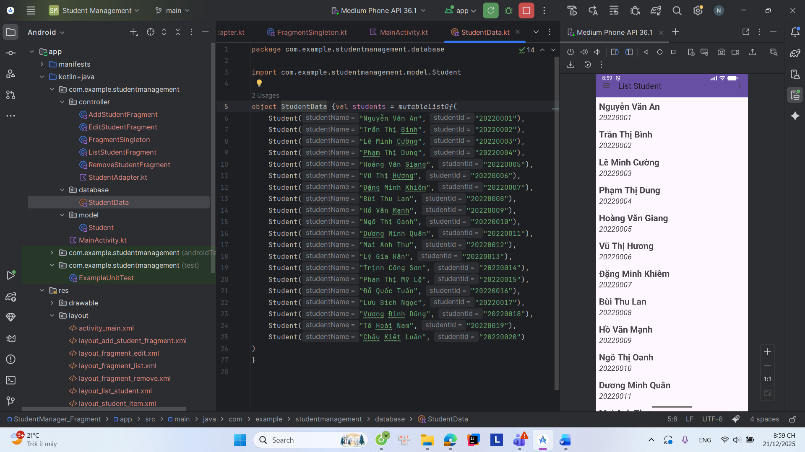
Màn hình thêm sinh viên:
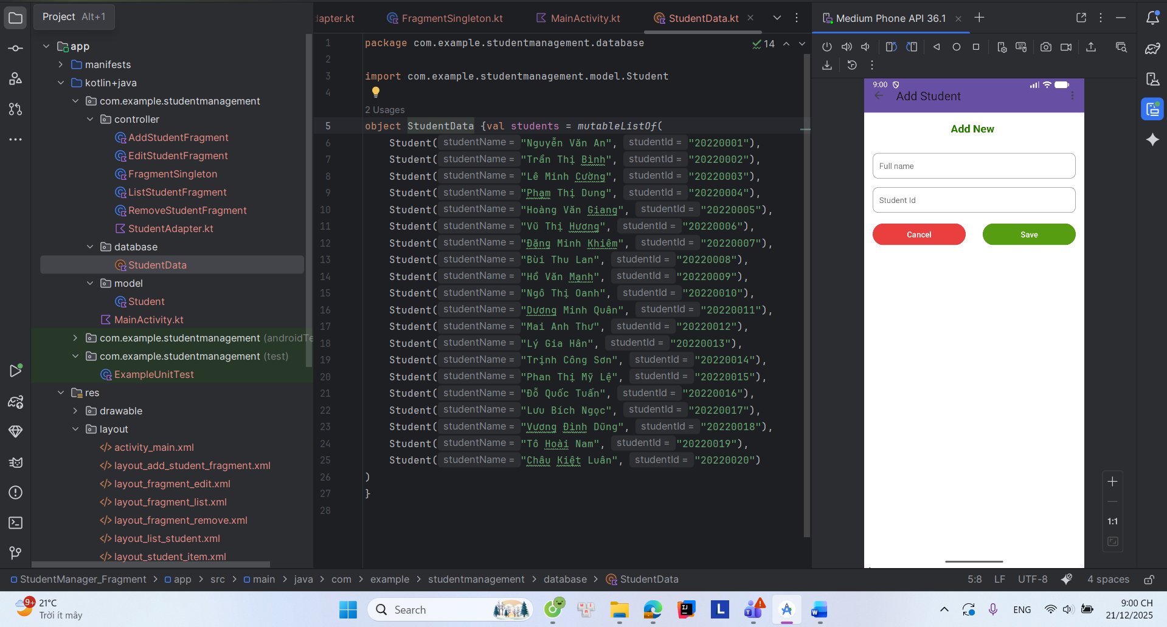

Thêm sinh viên:
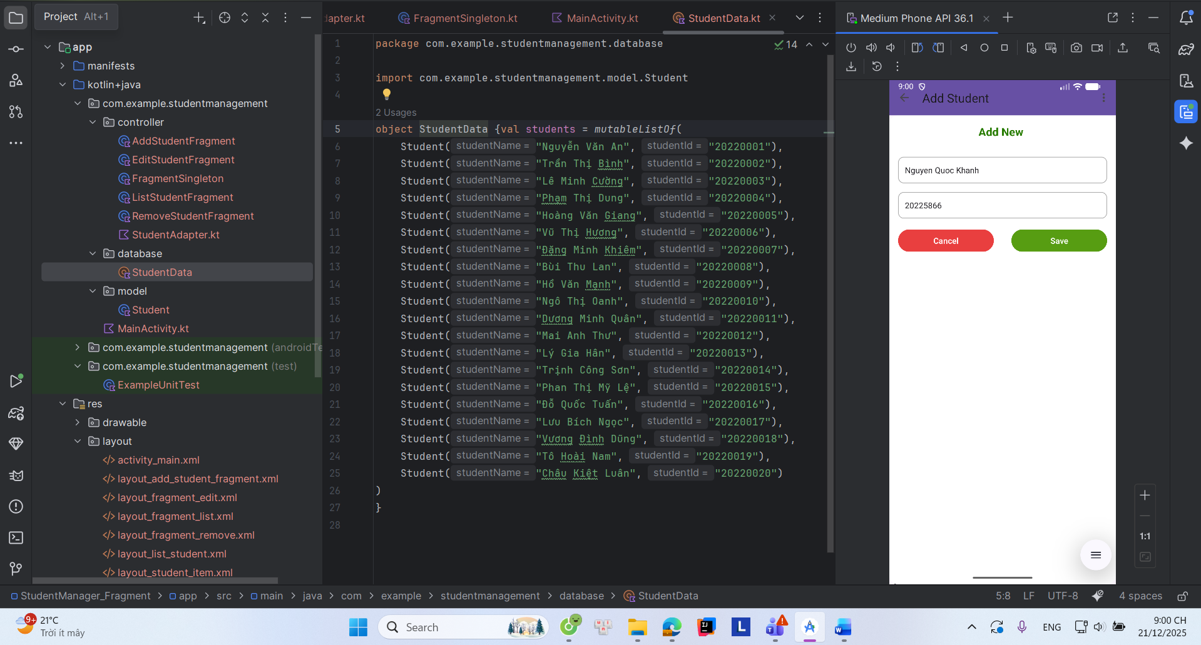
Danh sách sinh viên:
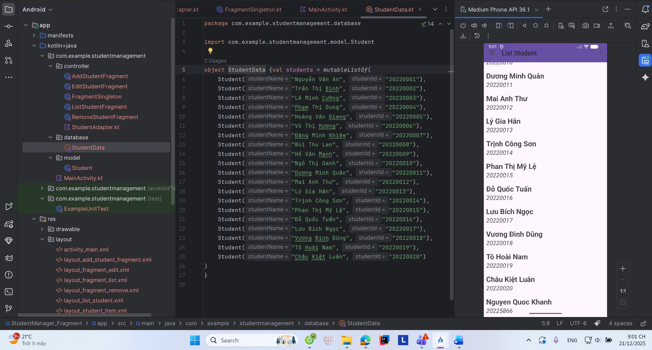

Chỉnh sửa sinh viên:
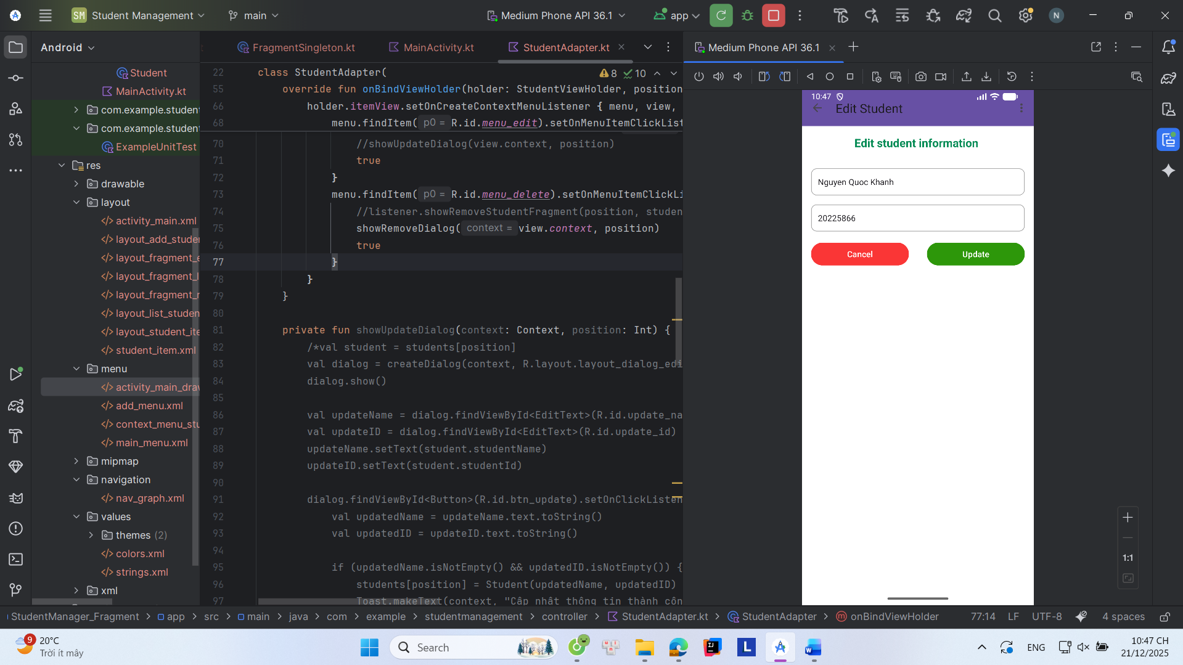
Sửa thành mã số sinh viên 20229999
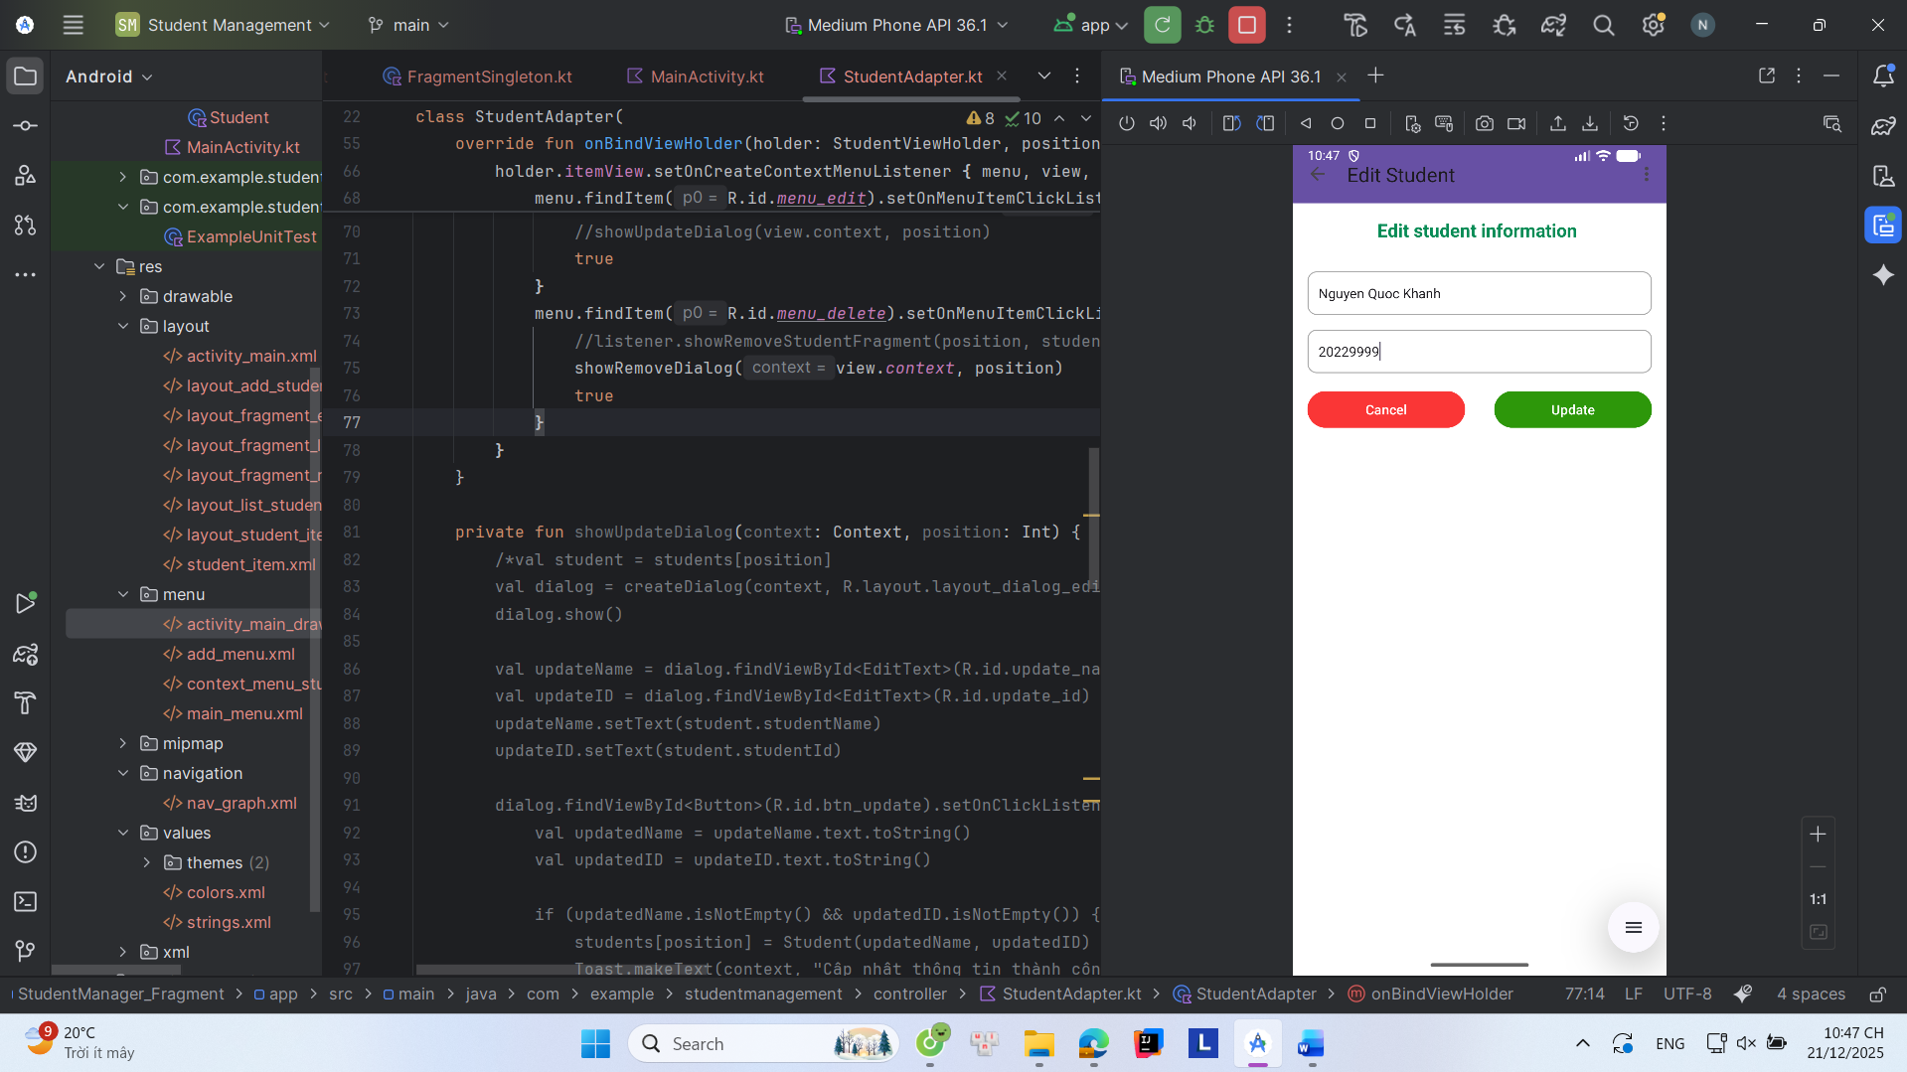

Kết quả sau khi sửa:
